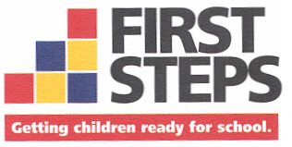
Horry County First Steps to School Readiness
Partnership Board Meeting
AGENDA
 | LaTonya Vereen |  | Shanta Dixon-Kindle |  | Angela Grissett
 | Sabrina Long |  | Lynn McKiernan |  | Stacy LoCasio
 | Jennifer Cusack |  | Kim Inman
February 4, 2025 – 5:30 p.m.
1511 9th Avenue, Suite A
Conway SC 29526

Issue

Roll Call

Call to Order and Approve Agenda
Action Item: Adoption of the agenda as presented

Approval of previous meeting minutes
Attachments: November and January meeting minutes
Action Item: Approval of November and January meeting minutes

Adoption of Amended Bylaws
Attachments: HCFS Amended Bylaws
Resolution for Adoption of Amended Bylaws
Summary of Amended Bylaws
Action Item: Resolution for Adoption of Amended Bylaws

Financial Update
Attachments: Board Report Category Budget vs. Expenses Report

Executive Director’s Report (Amy Breault)
Attachments: Performance Matrix

Motion: To adjourn the meeting of the HCFS Partnership Board

This meeting is being held within FOIA and ADA compliance. Persons with special needs should contact Amy Breault at 843-488-3336 by January 31, 2025 to make the necessary arrangements

This meeting will also take place via Zoom:

https://us02web.zoom.us/j/8434883336

Meeting ID:843 488 3336

